## **Qwiklabs Assessment: Log Analysis Using Regular Expressions**

## **Introduction**

Imagine your company uses a server that runs a service called ticky, an internal ticketing system. The service logs events to syslog, both when it runs successfully and when it encounters errors.

The service's developers need your help getting some information from those logs so that they can better understand how their software is used and how to improve it. So, for this lab, you'll write some automation scripts that will process the system log and generate reports based on the information extracted from the log files.

## **What you'll do**

* Use regex to parse a log file
* Append and modify values in a dictionary
* Write to a file in CSV format
* Move files to the appropriate directory for use with the CSV->HTML converter

**You'll have 90 minutes to complete this lab.**

Log Analysis Using Regular Expressions

linux-instance external IP address



content\_copy

username



content\_copy

[file\_download](https://googlecoursera.qwiklabs.com/lab_instances/download_pem/15970457" \t "_blank)

[Download PEM](https://googlecoursera.qwiklabs.com/lab_instances/download_pem/15970457" \t "_blank)

[file\_download](https://googlecoursera.qwiklabs.com/lab_instances/download_ppk/15970457" \t "_blank)

[Download PPK](https://googlecoursera.qwiklabs.com/lab_instances/download_ppk/15970457" \t "_blank)

## Introduction

Imagine your company uses a server that runs a service called ticky, an internal ticketing system. The service logs events to syslog, both when it runs successfully and when it encounters errors.

The service's developers need your help getting some information from those logs so that they can better understand how their software is used and how to improve it. So, for this lab, you'll write some automation scripts that will process the system log and generate reports based on the information extracted from the log files.

#### **What you'll do**

* Use regex to parse a log file
* Append and modify values in a dictionary
* Write to a file in CSV format
* Move files to the appropriate directory for use with the CSV->HTML converter

You'll have 90 minutes to complete this lab.

### **Start the lab**

You'll need to start the lab before you can access the materials in the virtual machine OS. To do this, click the green “Start Lab” button at the top of the screen.

**Note:** For this lab you are going to access the **Linux VM** through your **local SSH Client**, and not use the **Google Console** (**Open GCP Console** button is not available for this lab).

Start Lab

After you click the “Start Lab” button, you will see all the SSH connection details on the left-hand side of your screen. You should have a screen that looks like this:

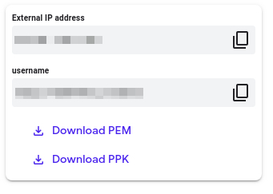

## Accessing the virtual machine

Please find one of the three relevant options below based on your device's operating system.

**Note:** Working with Qwiklabs may be similar to the work you'd perform as an **IT Support Specialist**; you'll be interfacing with a cutting-edge technology that requires multiple steps to access, and perhaps healthy doses of patience and persistence(!). You'll also be using **SSH** to enter the labs -- a critical skill in IT Support that you’ll be able to practice through the labs.

### **Option 1: Windows Users: Connecting to your VM**

In this section, you will use the PuTTY Secure Shell (SSH) client and your VM’s External IP address to connect.

**Download your PPK key file**

You can download the VM’s private key file in the PuTTY-compatible **PPK** format from the Qwiklabs Start Lab page. Click on **Download PPK**.

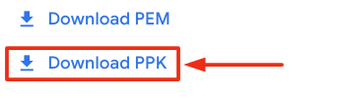

**Connect to your VM using SSH and PuTTY**

1. You can download Putty from [here](https://the.earth.li/~sgtatham/putty/latest/w64/putty.exe)
2. In the **Host Name (or IP address)** box, enter username@external\_ip\_address.

**Note:** Replace **username** and **external\_ip\_address** with values provided in the lab.



1. In the **Category** list, expand **SSH**.
2. Click **Auth** (don’t expand it).
3. In the **Private key file for authentication** box, browse to the PPK file that you downloaded and double-click it.
4. Click on the **Open** button.

**Note:** PPK file is to be imported into PuTTY tool using the Browse option available in it. It should not be opened directly but only to be used in PuTTY.



1. Click **Yes** when prompted to allow a first connection to this remote SSH server. Because you are using a key pair for authentication, you will not be prompted for a password.

**Common issues**

If PuTTY fails to connect to your Linux VM, verify that:

* You entered **<username>**@**<external ip address>** in PuTTY.
* You downloaded the fresh new PPK file for this lab from Qwiklabs.
* You are using the downloaded PPK file in PuTTY.

### **Option 2: OSX and Linux users: Connecting to your VM via SSH**

**Download your VM’s private key file.**

You can download the private key file in PEM format from the Qwiklabs Start Lab page. Click on **Download PEM**.

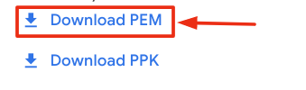

**Connect to the VM using the local Terminal application**

A **terminal** is a program which provides a **text-based interface for typing commands**. Here you will use your terminal as an SSH client to connect with lab provided Linux VM.

1. Open the Terminal application.
   * To open the terminal in Linux use the shortcut key **Ctrl+Alt+t**.
   * To open terminal in **Mac** (OSX) enter **cmd + space** and search for **terminal**.
2. Enter the following commands.

**Note:** Substitute the **path/filename for the PEM** file you downloaded, **username** and **External IP Address**.

You will most likely find the PEM file in **Downloads**. If you have not changed the download settings of your system, then the path of the PEM key will be **~/Downloads/qwikLABS-XXXXX.pem**

chmod 600 ~/Downloads/qwikLABS-XXXXX.pem

ssh -i ~/Downloads/qwikLABS-XXXXX.pem username@External Ip Address

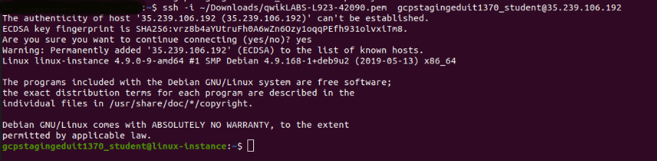

### **Option 3: Chrome OS users: Connecting to your VM via SSH**

**Note:** Make sure you are not in **Incognito/Private mode** while launching the application.

**Download your VM’s private key file.**

You can download the private key file in PEM format from the Qwiklabs Start Lab page. Click on **Download PEM**.



**Connect to your VM**

1. Add Secure Shell from [here](https://chrome.google.com/webstore/detail/secure-shell-app/pnhechapfaindjhompbnflcldabbghjo) to your Chrome browser.
2. Open the Secure Shell app and click on **[New Connection]**.

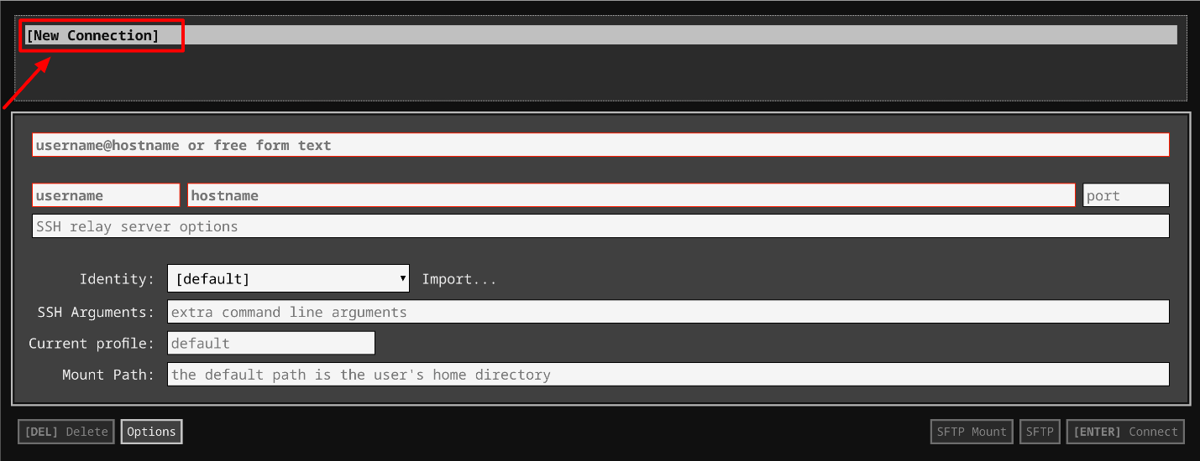

1. In the **username** section, enter the username given in the Connection Details Panel of the lab. And for the **hostname** section, enter the external IP of your VM instance that is mentioned in the Connection Details Panel of the lab.

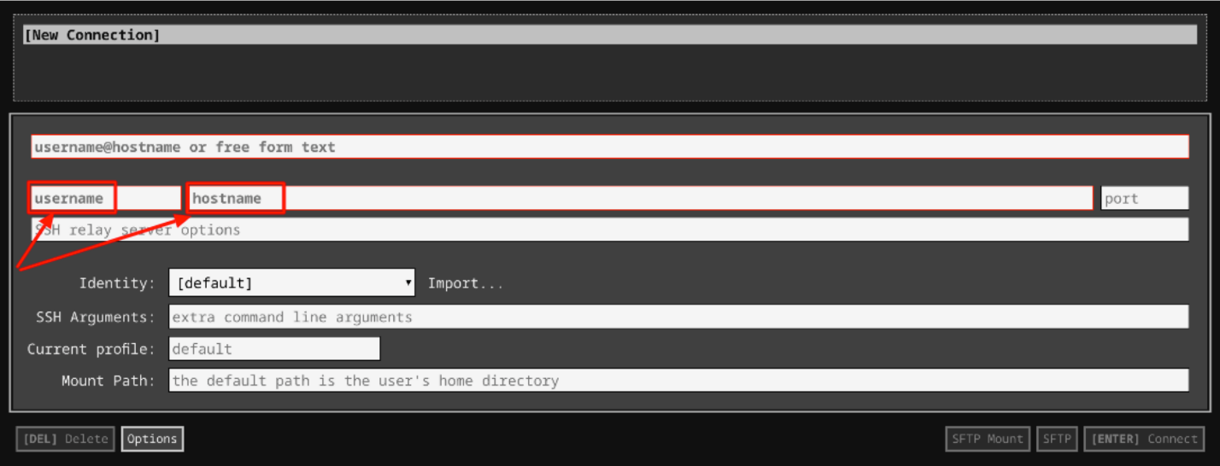

1. In the **Identity** section, import the downloaded PEM key by clicking on the **Import…** button beside the field. Choose your PEM key and click on the **OPEN** button.

**Note:** If the key is still not available after importing it, refresh the application, and select it from the **Identity** drop-down menu.

1. Once your key is uploaded, click on the **[ENTER] Connect** button below.

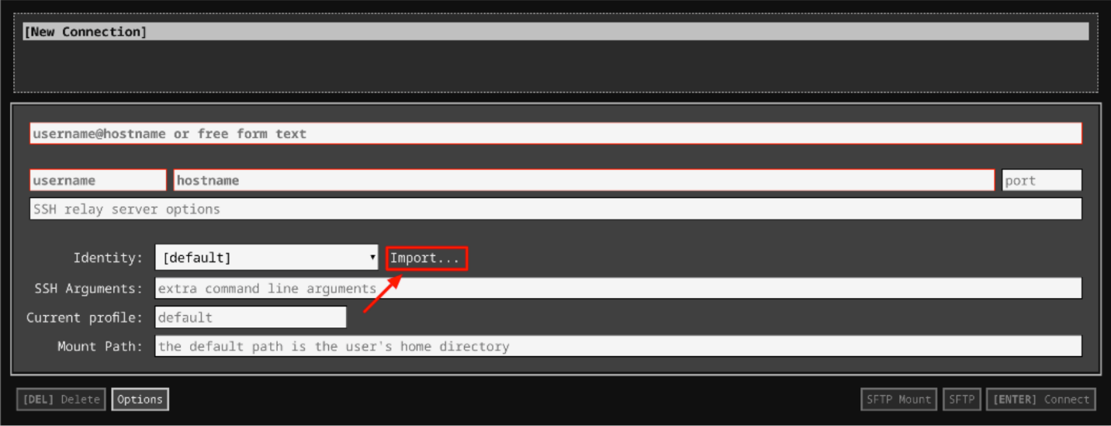

1. For any prompts, type **yes** to continue.
2. You have now successfully connected to your Linux VM.

You're now ready to continue with the lab!

## Exercise - 1

We'll be working with a log file named **syslog.log**, which contains logs related to ticky.

You can view this file using:

cat syslog.log

The log lines follow a pattern similar to the ones we've seen before. Something like this:

May 27 11:45:40 ubuntu.local ticky: INFO: Created ticket [#1234] (username)

Jun 1 11:06:48 ubuntu.local ticky: ERROR: Connection to DB failed (username)

When the service runs correctly, it logs an INFO message to syslog. It then states what it did and states the username and ticket number related to the event. If the service encounters a problem, it logs an ERROR message to syslog. This error message indicates what was wrong and states the username that triggered the action that caused the problem.

In this section, we'll search and view different types of error messages. The error messages for ticky details the problems with the file with a timestamp for when each problem occurred.

These are a few kinds of listed error:

* Timeout while retrieving information
* The ticket was modified while updating
* Connection to DB failed
* Tried to add information to a closed ticket
* Permission denied while closing ticket
* Ticket doesn't exist

To grep all the logs from ticky, use the following command:

grep ticky syslog.log

Output:

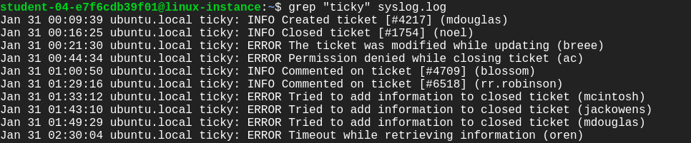

In order to search all the **ERROR** logs, use the following command:

grep "ERROR" syslog.log

Output:

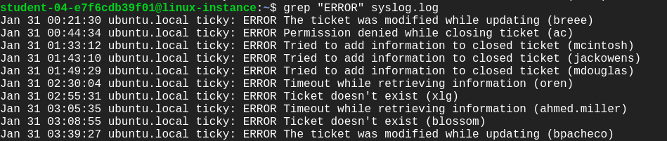

To enlist all the ERROR messages of specific kind use the below syntax.

**Syntax:** grep ERROR [message] [file-name]

grep "ERROR Tried to add information to closed ticket" syslog.log

Output:

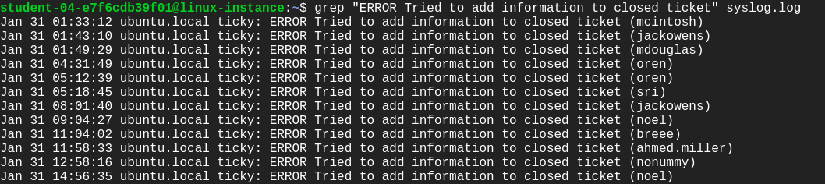

Let's now write a few regular expressions using a python3 interpreter.

We can also grep the ERROR/INFO messages in a pythonic way using a regular expression. Let's now write a few regular expressions using a **python3** interpreter.

Open **Python shell** using the command below:

python3

This opens a **Shell**. Python provides a **Python Shell** (also known as **Python** Interactive **Shell**), which is used to execute a single **Python** command and get the result.

Import the regular expression module (re).

import re

line = "May 27 11:45:40 ubuntu.local ticky: INFO: Created ticket [#1234] (username)"

To match a string stored in **line** variable, we use the search() method by defining a pattern.

re.search(r"ticky: INFO: ([\w ]\*) ", line)

Output:

<\_sre.SRE\_Match object; span=(29, 57), match='ticky: INFO: Created ticket '>

You can also get the **ERROR** message as we did for the **INFO** log above from the ERROR log line.

line = "May 27 11:45:40 ubuntu.local ticky: ERROR: Error creating ticket [#1234] (username)"

To match a string stored in a **line** variable, we use the search() method by defining a pattern.

re.search(r"ticky: ERROR: ([\w ]\*) ", line)

Output:

<\_sre.SRE\_Match object; span=(29, 65), match='ticky: ERROR: Error creating ticket '>

Now that you know how to use regular expressions with Python, start fetching logs of ticky for a specific username. We'll need them in later sections.

## Exercise - 2

Now, use the Python interactive shell to create a dictionary.

fruit = {"oranges": 3, "apples": 5, "bananas": 7, "pears": 2}

Call the sorted function to sort the items in the dictionary.

sorted(fruit.items())

Output:

[('apples', 5), ('bananas', 7), ('oranges', 3), ('pears', 2)]

We'll now sort the dictionary using the item's key. For this use the **operator** module.

Pass the function itemgetter() as an argument to the sorted() function. Since the second element of tuple needs to be sorted, pass the argument 0 to the itemgetter function of the **operator** module.

import operator

sorted(fruit.items(), key=operator.itemgetter(0))

Output:

[('apples', 5), ('bananas', 7), ('oranges', 3), ('pears', 2)]

To sort a dictionary based on its **values**, pass the argument 1 to the itemgetter function of the **operator** module.

sorted(fruit.items(), key=operator.itemgetter(1))

Output:

[('pears', 2), ('oranges', 3), ('apples', 5), ('bananas', 7)]

Finally, you can also reverse the order of the sort using the **reverse** parameter. This parameter takes in a boolean argument.

To sort the fruit object from most to least occurrence, we pass the argument reverse=True.

sorted(fruit.items(), key = operator.itemgetter(1), reverse=True)

Output:

[('bananas', 7), ('apples', 5), ('oranges', 3), ('pears', 2)]

You can see the fruit object is now sorted from the most to the least number of occurrences.

Great job practice these skills! You can further practice this by sorting the logs that you would fetch using regular expressions from the previous section.

Exit the shell using exit().

## Exercise - 3

We'll now work with a file named **csv\_to\_html.py**. This file converts the data in a CSV file into an HTML file that contains a table with the data. Let's practice this with an example file.

Create a new CSV file.

nano user\_emails.csv

Add the following data into the file:

Full Name, Email Address

Blossom Gill, blossom@abc.edu

Hayes Delgado, nonummy@utnisia.com

Petra Jones, ac@abc.edu

Oleg Noel, noel@liberomauris.ca

Ahmed Miller, ahmed.miller@nequenonquam.co.uk

Macaulay Douglas, mdouglas@abc.edu

Aurora Grant, enim.non@abc.edu

Madison Mcintosh, mcintosh@nisiaenean.net

Montana Powell, montanap@semmagna.org

Rogan Robinson, rr.robinson@abc.edu

Simon Rivera, sri@abc.edu

Benedict Pacheco, bpacheco@abc.edu

Maisie Hendrix, mai.hendrix@abc.edu

Xaviera Gould, xlg@utnisia.net

Oren Rollins, oren@semmagna.com

Flavia Santiago, flavia@utnisia.net

Jackson Owens, jackowens@abc.edu

Britanni Humphrey, britanni@ut.net

Kirk Nixon, kirknixon@abc.edu

Bree Campbell, breee@utnisia.net

Save the file by clicking Ctrl-o, Enter key, and Ctrl-x.

Give executable permission to the script file **csv\_to\_html.py**.

sudo chmod +x csv\_to\_html.py

To visualize the data in the **user\_emails.csv** file, you have to generate a webpage that'll be served by the webserver running on the machine.

The script **csv\_to\_html.py** takes in two arguments, the CSV file, and location that would host the HTML page generated. Give write permission to the directory that would host that HTML page:

sudo chmod o+w /var/www/html

Next, run the script **csv\_to\_html.py** script by passing two arguments: user\_emails.csv file and the path /var/www/html/. Also, append a name to the path with an HTML extension. This should be the name that you want the HTML file to be created with.

./csv\_to\_html.py user\_emails.csv /var/www/html/<html-filename>.html

Replace <html-filename> with the new name.

Navigate to the /var/www/html directory. Here, you'll find an HTML file created with the filename you passed to the above script.

ls /var/www/html

Now, to view this HTML page, open any web-browser and enter the following URL in the search bar.

**[linux-instance-external-IP]**/**[html-filename].html**

Output:

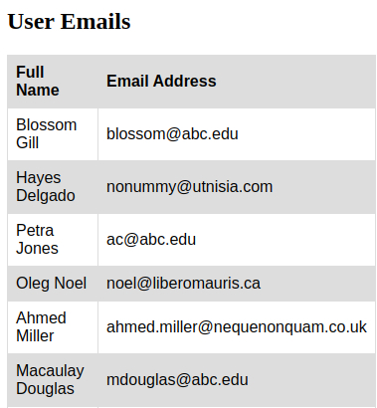

You should now be able to visualize the data within the user\_emails.csv file on a webpage.

## Generate reports

Now, we're going to practice creating a script, named **ticky\_check.py**, that generates two different reports from this internal ticketing system log file i.e., syslog.log. This script will create the following reports:

* **The ranking of errors generated by the system**: A list of all the error messages logged and how many times each error was found, sorted by the most common error to the least common error. This report doesn't take into account the users involved.
* **The user usage statistics for the service**: A list of all users that have used the system, including how many info messages and how many error messages they've generated. This report is sorted by username.

To create these reports write a python script named ticky\_check.py. Use nano editor for this.

nano ticky\_check.py

Add the shebang line.

#!/usr/bin/env python3

Here's your challenge: Write a script to generate two different reports based on the ranking of errors generated by the system and the user usage statistics for the service. You'll write the script on your own, but we'll guide you throughout.

First, import all the Python modules that you'll use in this Python script. After importing the necessary modules, initialize two dictionaries: one for the number of different error messages and another to count the number of entries for each user (splitting between INFO and ERROR).

Now, parse through each log entry in the syslog.log file by iterating over the file.

For each log entry, you'll have to first check if it matches the **INFO** or **ERROR** message formats. You should use regular expressions for this. When you get a successful match, add one to the corresponding value in the per\_user dictionary. If you get an **ERROR** message, add one to the corresponding entry in the error dictionary by using proper data structure.

After you've processed the log entries from the syslog.log file, you need to sort both the per\_user and error dictionary before creating CSV report files.

Keep in mind that:

* The error dictionary should be sorted by the number of errors from most common to least common.
* The user dictionary should be sorted by username.

Insert column names as ("Error", "Count") at the zero index position of the sorted error dictionary. And insert column names as ("Username", "INFO", "ERROR") at the zero index position of the sorted per\_user dictionary.

After sorting these dictionaries, store them in two different files: **error\_message.csv** and **user\_statistics.csv**.

Save the **ticky\_check.py** file by clicking Ctrl-o, Enter key, and Ctrl-x.

## Visualize reports

First, give executable permission to the Python script ticky\_check.py.

chmod +x ticky\_check.py

Run the ticky\_check.py by using the following command:

./ticky\_check.py

Executing ticky\_check.py will generate two report file \_\_error\_message.csv \_\_and **user\_statistics.csv**.

You can now visualize the \_\_error\_message.csv \_\_and **user\_statistics.csv** by converting them to HTML pages. To do this, pass the files one by one to the script **csv\_to \_html.py** file, like we did in the previous section.

To convert the **error\_message.csv** into HTML file run the following command:

./csv\_to\_html.py error\_message.csv /var/www/html/<html-filename>.html

Replace <html-filename> with the name of your choice.

To convert **user\_statistics.csv** into HTML file, run the following command:

./csv\_to\_html.py user\_statistics.csv /var/www/html/<html-filename>.html

Replace <html-filename> with the new name

Now, to view these HTML pages, open any web-browser and enter the following URL in the search bar.

**[linux-instance-external-IP]**/**[html-filename].html**

Output:

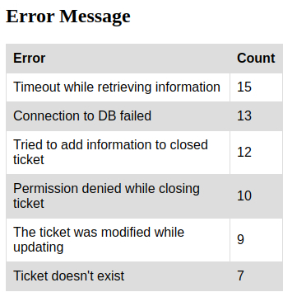

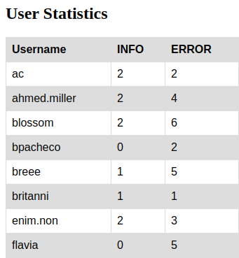

Click Check my progress to verify the objective.

Generate two CSV report files and visualize data on the web

Check my progress

It doesn't look like you've completed this step yet. Try again.

## Congratulations!

Congrats! You've successfully written some automation scripts that process the system log and generate a bunch of reports based on the information extracted from the log files. You have also hosted these reports on a webpage. As an IT specialist, this will help you to work with Python scripting to generate HTML tabular data for data visualization.

## End your lab